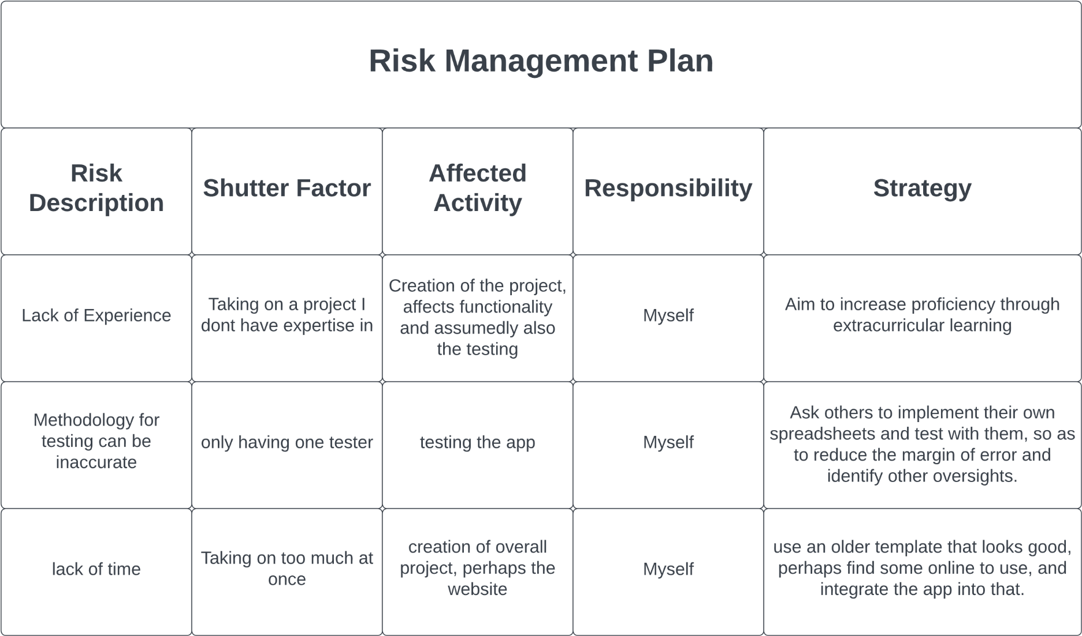

Google will have to become my new best friend

Finishing creation of prototype

Don’t know how to mount an app like that

Myself

Inability to host online